Node.js is a programming tool that uses an open sourced command line tool. This tool is built for the java script in Google’s Chrome browser. Node.js was invented to create websites with push capabilities, build fast network applications and it has a built-in web server protocol. If you’ve ever used PHP, Node.js is the JavaScript equivalent to this.
You can build many web based products with Node.js like build chatrooms, remotely control programmable electronics, create API’s, build collaborative tools and so much more! The uses for node.js are endless.
To use node.js you will have to use the command prompt to write various coding. This coding will enable the program to create new applications. Coding is the basis of every computer program and is necessary to successfully operate a computer on and offline.
There is no right and wrong way to code a program once the code is successful the program will work. This is why there are always bugs to work out when a program is first created. The programmers have to run each code in the programs to ensure that everything works okay.
There are endless possibilities to creating programs and applications in node.js. This tool is great if you would like to create java applications and it is simple enough to use that a novice coder can create functional programs in hours.
Node.js was not originally built to support Windows 10 on its own you must install a few programs to help it along. To install and run Node.js on Windows 10 you must complete the following steps:
- Download Git. Git is a program that takes various screen shots of while it is running. This is important for node users not to lose their work because of a program crash. You can download Git from their website at:

https://git-scm.com/book/en/v2/Getting-Started-Git-Basics

- To ensure that the program installs properly download the Node.js .msi Installer. There is an installer for each operating system made and you can find the downloads at the node.js website:

https://nodejs.org/en/download/

- Install the setup package from the Node.js website:
https://nodejs.org/en/

The download package for windows is on the website home page. If this is your first time installing the program or you are a novice user choose the package on the left which indicates for most users.
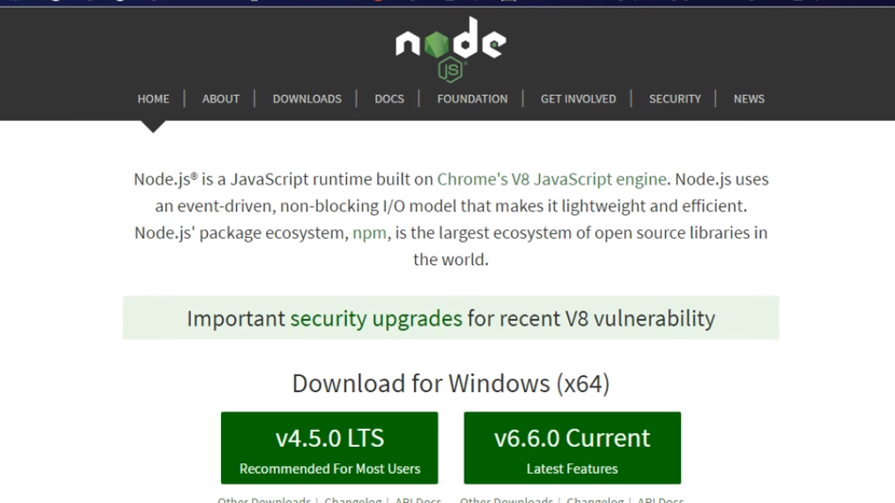
- Once the setup package has been downloaded it will most likely appear at the bottom of the screen. Open the file and click on next and then follow the on screen instructions.

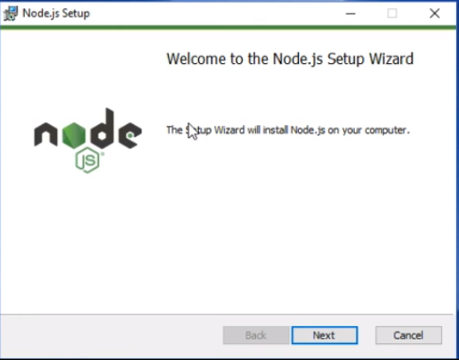
- The node package manager is essential to using node. This package manager holds a lot of tools necessary to build applications. If you would like to select the NPM package for the installation select NPM Package Manager on the custom set up screen. This feature requires extra space on your hard drive. Ensure that there is enough space for this package or the installation will fail.
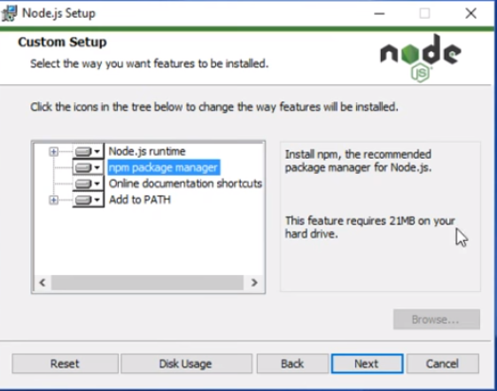
- Go through the installation and finish the on-screen prompts for the installation process by clicking next and okay. Once you have agreed to all of the parts of the setup the installer will let you know when all of the components have been installed.

- Once the program has been completely installed Restart your computer. Restarting your computer is essential to the installation process because some components can only be installed when the computer is being restarted.

- After you’ve restarted your system click on search at the bottom left corner of your menu bar and type Command Prompt. Select the command prompt program from the list and double click on it to open it. You can also find the command prompt in your system tools menu in the start menu.
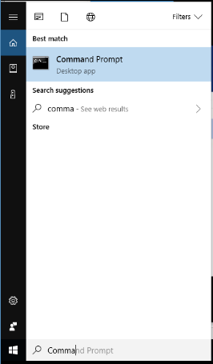
- Once you’ve opened command prompt type node -v and hit enter. Underneath this line a version number should appear similar to v0.10.35. This indicates that node.js was successfully installed and it is ready to be used.

- To see if the installation of NPM was successful type npm -v in the command prompt. A version number resembling, 1.4.28 should appear.

- Update the Local npm Version. There is almost always a newer version of npm that is different from the version you can download from the installation. Node.js does not auto update its’ npm. To find the latest version of npm run the following command:
npm install npm --global // Update the `npm` CLI client
The best way to use node.js is to install the express application generator. You can do this by following these steps:
- In the command prompt type the following command to install the express application generator
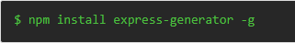
- Once the installation is finished type -h to view all of the command options available
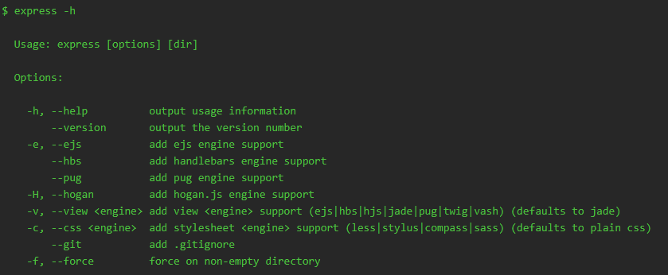
Once you have generated the command list, you can use the commands in the table to generate applications and web browsing capabilities.
Although it seems bothersome to install this program on a computer that runs Windows 10 it is worth the trouble. Node.js can create programs using simple coding procedures that will enable users to develop their skills. There are no short cuts to creating programing for applications and even in node.js there are some issues. These issues will resolve themselves once the user gets to know what they’re doing.

